A Folder Title (‘Heading 1’ style)
Description in folder (‘Normal Folder’ Style)

Title First Requirement (Heading 6 style)
Description first requirement (‘Normal’ Style)
Importing items with a hierarchy can be achieved using, words’ number Heading style, the hierarchy is build based on the numbers.
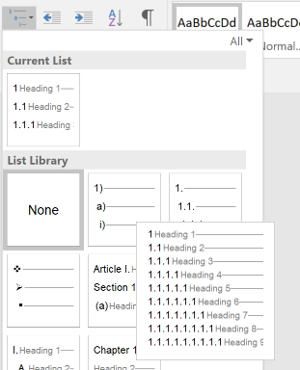
When importing from word, the import can be automated using the word styles. It is important that each entry field in Matrix (including the title) has one matching style. In a normal simple category (e.g. REQ / requirements) you will need 4 styles:
A style for requirement titles, here ‘Heading 6’ without numbers
A style for requirement text, here ‘Normal’
A style for folder titles, here ‘Heading 1’ and ‘Heading 2’ with
A style for folder text, here ‘Normal Folder’ (a simple copy of the Normal style)
You can pick the styles yourself, the matching is done in the Matrix Word importer.

Title Second Requirement (Heading 6 style)

Another Folder (‘Heading 1’ style)

A Subfolder (‘Heading 2’ style)

Title Third Requirement (Heading 6 style)
Description Third Requirement (‘Normal’ Style)

